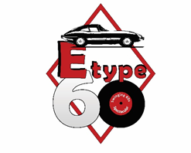

23 October 2020

For immediate release

Mini to join in the ‘Swinging Sixties’ E-type 60 Celebration

Owners of the humble yet much-adored Mini, in all its classic forms, are invited to join in the celebration of that other iconic sixties British classic - the Jaguar E-type - at its 60th anniversary event at Shelsley Walsh.

The two legendary cars often slug it out for the top spot in public votes on the Best British Car Ever, but for the weekend of 12-13 June 2021, any such rivalries will be put aside to celebrate 60 years since the launch of the E-type by reviving the cars, music and fashion of the ‘Swinging Sixties’.

One of the unifying features of the event will be an homage to the 1969 film ‘The Italian Job’, a movie which beautifully captured the mood, energy and cars of the carefree decade. The actual E-type used in the film - repaired and restored since its rather one-sided fight with a Mafia bulldozer - will be on show alongside a trio of red, white and blue Mini Coopers and the original six-wheeled coach, rescued from the cliff edge.

The organisers are delighted to have support from Mini legend Paddy Hopkirk MBE, whose relationship with the car started in 1963 with competitive racing on the Tour de France Automobile and the world-famous Monte Carlo Rally.

About the event:
Organised by the Jaguar E-type Club, E-TYPE 60 is celebrating 60 years since the launch of the E-type and the spectacular 'Swinging Sixties’ and is the only event dedicated to the E-type and its anniversary.

The weekend will be action-packed with activity on the hillclimb each day and all day, together with live entertainment focused on the 1960s and its outrageous trends.​

Competitive hillclimb classes will include Mini and E-type.

There will be plenty of special cars on display, including 9600 HP, the original E-type press car and oldest Fixed-Head Coupé and 77 RW, the first Open Two-Seater off the production line. Both were driven from the UK to the 1961 launch in Geneva.

Tickets and further information can be found at www.etype60.com

Book in Confidence - COVID-19 SECURE
The safety and well-being of all visitors to E-type 60 is a priority to us and although we are mindful that the pandemic situation will, undoubtedly, have changed course by June 2021, we will take whatever precautions necessary to safeguard visitors. We have registered compliance with Visit England to demonstrate that we will take the required action to welcome visitors in line with Government and Public Health England guidelines. Nearer to the event date, we will circulate details of these measures. Early Bird tickets are available from the event website www.etype60.com until 31 December and are refundable until that date.

About the Jaguar E-type Club:
Founded by Philip and Julie Porter in 2004 and the only club to focus 100% on the iconic model, the E-type Club now has members in over 50 countries; a truly international and growing membership. The Club’s emphasis is very much on using the cars – the E-type was designed to be driven!

Members of the E-type Club receive a monthly 72+ page magazine and can access a wide range of events many of which are free or at low cost to members. For those restoring or maintaining their cars, there is a wide range of meaningful discounts with many of the leading specialists, plus technical advice and all the practical features and tips in the magazine.

No committees, no concours, no politics and a very friendly atmosphere.

Find out more:

About the E-type Club
www.e-typeclub.com or email info@e-typeclub.com or telephone 01584 781588

Media enquiries
Rebecca Leppard, Eventageous PR - email rebecca@eventspr.co.uk or telephone 01452 260063

Media images
https://tinyurl.com/rhn9pt

Attach this image:

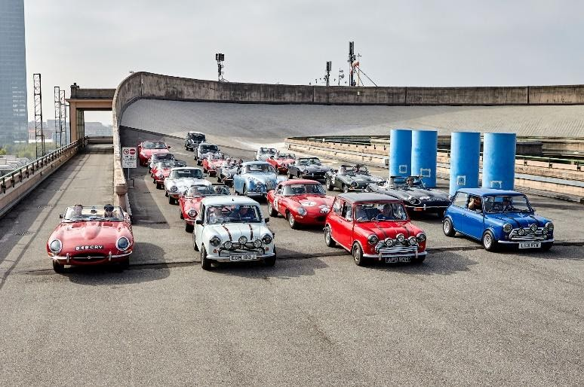

Minis and E-types celebrate the 60th anniversary of The Italian Job film on the rooftop of the former Fiat factory in Turin in 2019

