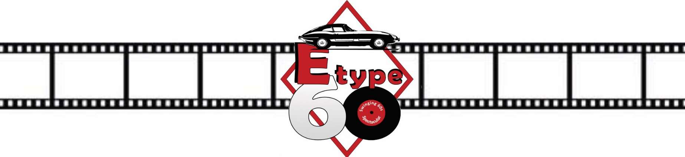

E-type 60 Media Application Form

Name:
Address:
Email:
Telephone number: | Mobile:

For which publication/organisation will you be working?

What is the print circulation/number of unique visitors per month/number of followers?

Name of editor/director

Which day would you like to attend? Saturday 12th June, Sunday 13th June or both?

Working primarily as:

 | Journalist |  | Photographer
 | TV/film |  | Blogger
 | Social media

I have read, understood and agree to abide by all applicable event guidelines pertaining to the E-type 60 event.
I acknowledge that the organisers shall be entitled to remove me from the venue and/or remove my media pass in the event of any breach or non-compliance of such guidelines.
I confirm that I am over 18 years of age and that I am physically and mentally fit to carry out my function and agree to inform the organisers immediately there is any change in such circumstances.
I acknowledge and accept that that due to the nature of motor racing, there are inherent risks and dangers to persons attending an event and that accidents may happen.

Signature:
Date:

