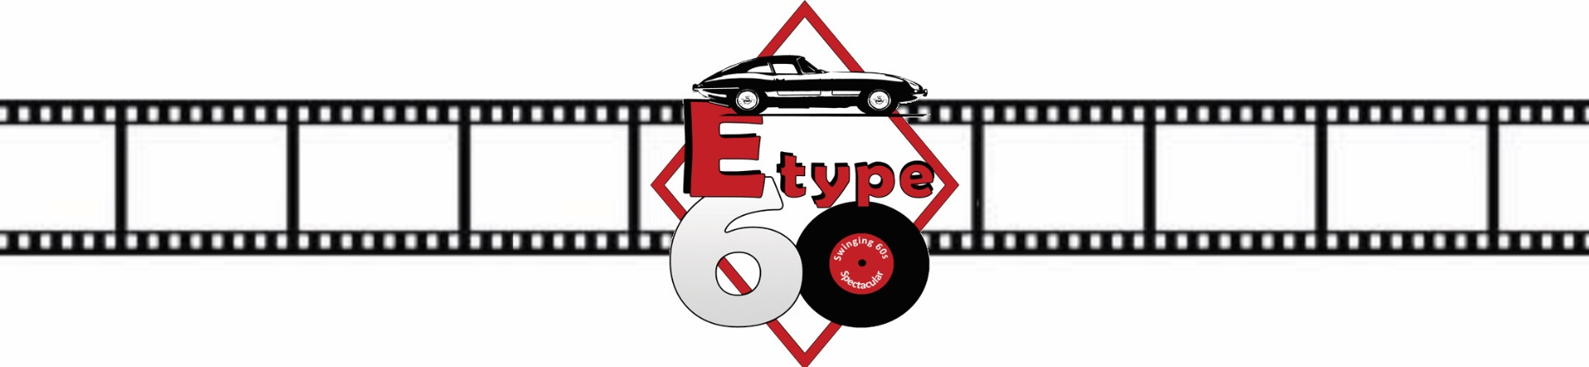

E-type 60 Media Application Guidelines

- One event entry ticket will be issued per application.
- Media passes will not be transferable to another name or date unless authorised by the Event Organisers in advance.
- On arrival, please sign on at the organisers’ office to be allocated your media pass, which is to be worn at all times whilst at the event.
- To qualify for a media pass, you must be active within the world of classic cars or motorsport, the automotive sector or Shelsley Walsh regional media.
- Your application must be supported by an original letter of accreditation from the editor or director of a recognised media organisation or a Guild of Motoring Writers or NUJ media card and
- Two examples of recently published work, and
- A copy of your public liability insurance (if you wish to photograph track-side).
- The granting of a media pass is entirely at the discretion of the organisers.
- All applications must be received by Monday 31 May 2021.

